A full description of what I did to code is in the code itself at the bottom, this is a very general overview and should be looked at after my code is reviewed.

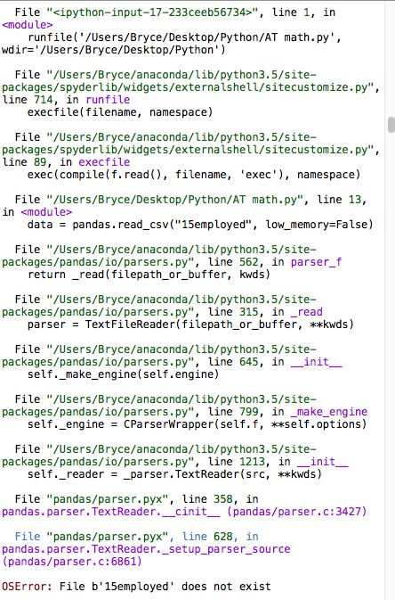

This was the error message when I tried to import data from the file.
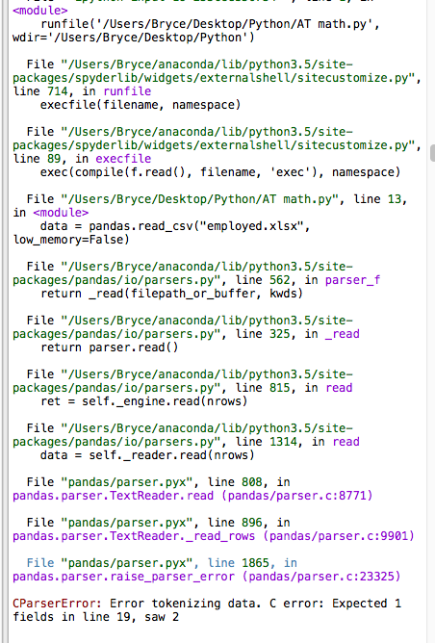
This is the error message I got when the data imported but was not set up correctly.
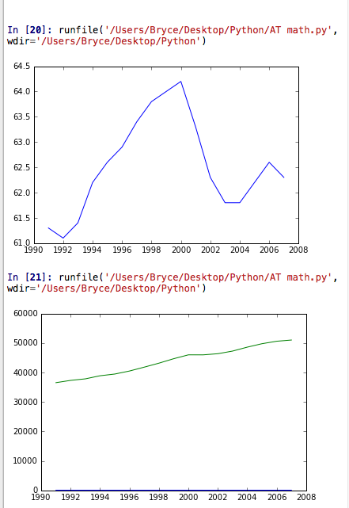

This is the graph that didn’t work because the scale was way off.
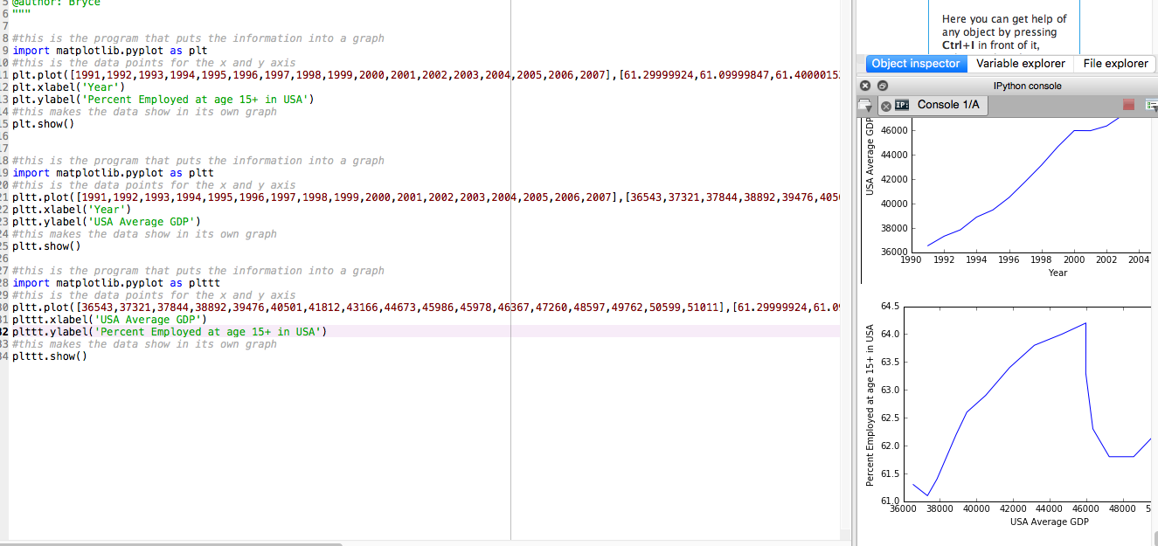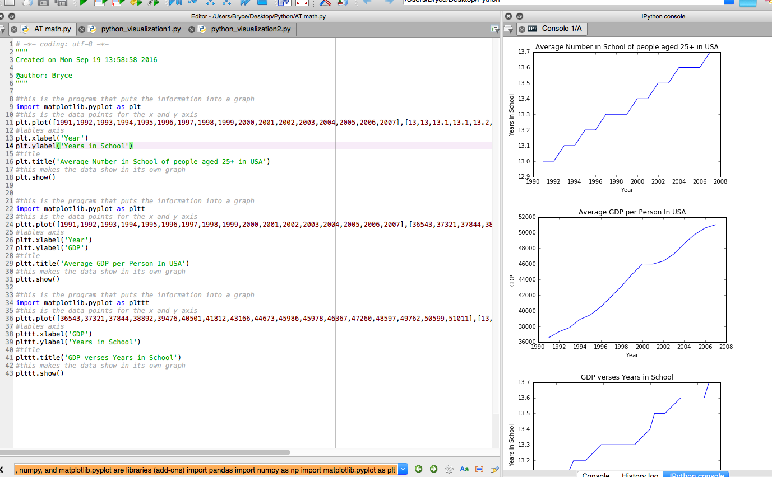
Two examples of me trying to fix the two original graphs and add a third.
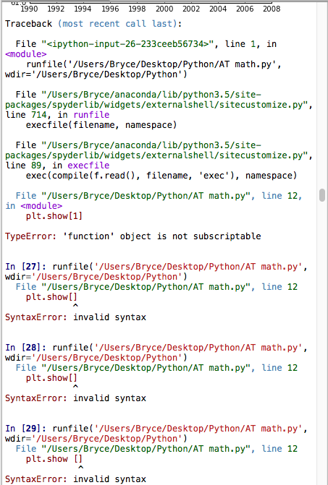

This was when I was trying to add color to the lines of the graphs but my syntax was wrong.

