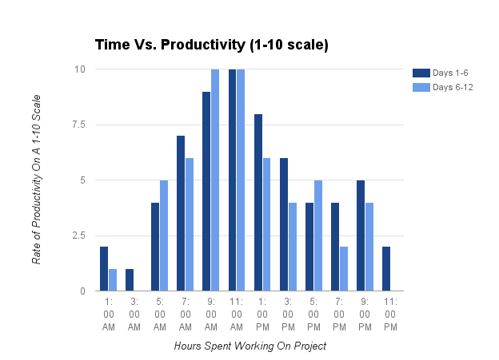

This is self collected data over the twelve days actively spent working on the project. Some days I did not even work on math at all, and that is why I only have data collected for 12 days. Every day recorded I scheduled time to work on the project and rating myself on a scale from 0-10 on how well I thought that session went. The definitions of the experiment are listed below. I worked three times at each hour period set and at the end chose a number from 1-10 that best represented my work and progress during those time slots. As you can see, this is unimodal and has a peak around mid-day suggesting that between 9AM-12PM are the most productive hours spent on this project. What you may also notice, is that later, and earlier in the day my productivity slowed down dramatically. At 3AM for days 6-12, you may notice I did absolutely no work, as I was asleep during that time which explains the 0 I rated myself there. The median of this data shows that my most productive hours are at 10:30AM. I can use this data to support my future learning now that I understand when my most productive work times are for long-term projects. My hypothesis is that if I am to work hard during the peak hours, then my productivity will increase dramatically on whatever I am working on.

Definitions

Definitions of the 1-10 scale:

0= no time or effort spent during this session
1= minimal effort, not any contributions, perhaps a small touch up to the project
2= minimal effort, no new contributions to the code. Perhaps a new insight was acquired
3= minimal effort, no new contributions to the code. Perhaps an application of a new insight
4= some effort, no new contributions to code. Perhaps a new insight acquired and applied
5= some effort, perhaps a new contribution to the code. No new insights acquired
6= some productivity, added new contributions to the code, and perhaps gained new insight. Used some problem solving effectively.
7= productive, time well spent. Took new insight and applied it to the code. May have used some problem solving effectively.
8= quite productive. Took project to the next level. Learned and applied new insight to further the project. Code worked as written. May have used problem solving effectively
9= quite productive, found new insights and applied them to the code. Code probably worked as written. Used problem solving effectively
10= Most productive. Time very well spent, insights created products. Code works and am able to understand the code as written. Used problem solving effectively.

Days 1-6 include: 30th, 31st of August and 2nd, 5th, 7th, and 12th of September
Days 6-12 include: 13th, 15th, 16th, 17th, 18th, 19th, and 20th of September

