September 21st, 2016
Andrew Edds
Concerned Resident of Singapore
6 Orange Grove Road, #10-00, The Vantage
Singapore, Singapore 258331

Dear Minister Fu,
I am writing to you because as the Minister of Community Development, Youth and Sports, I have an idea that can help us improve the lives of at-risk youth, here in Singapore. As an expatriate who has lived their entire lives here in Singapore, I have an interesting perspective on Singapore culture and standards. In the expat community, we are often hidden from the truth about crime in Singapore. In reality, despite the fact that crime rates are low, crime is still prevalent in Singapore. To quote magazine Expat Living Singapore, “Low crime in Singapore doesn’t mean no crime” (1).
During my time in Singapore I have developed friendships with many Singaporean local students through my passion for skateboarding. The relationships I have gained through skateboarding have always been very important to me, but I only recently realised how important skateboarding has been for my local friends. For these youth members that I have become so close with, skateboarding has represented a way to avoid the troubles that expats are often hidden from, yet I uncovered the truth through these young children. Whether it be gangs, drugs, or violence, these friends of mine all resorted to skateboarding and spending time at the skate parks as a way to avoid the youth crime here in Singapore.
There is a portion of Singapore that not only home to gangs and drugs, but it is home to my friends. The Punggol region of Singapore is home to my friends and other at-risk youth that are looking for a way out. I believe that the implementation of a skate park in the Punggol neighbourhood would be extremely beneficial to the youth living there and to Singapore as a whole.
To quote Tony Hawk, arguably the most famous skateboarder and philanthropist from the skateboarding world, skate parks are “a gathering place for dedicated, athletic youth, the skatepark provides the forum for visitors young and old, beginning and skilled, to meet and share experiences.” (The Tony Hawk Foundation). Tony Hawk has set up the Tony Hawk Foundation to help provide the resources to make those great things happen, and I believe that we should do the same even further here in Singapore.
Skateparks will not only benefit the students of Singapore by giving them an outlet to gain experiences, but it will also help lower the violent crime rates and juvenile arrests here in Singapore. According to the Ministry of Social and Family Development, 1,445 juveniles were arrested in 2015 alone, in addition, there were 535 violent crimes in Singapore in 2014 (Singapore Crime Brief 2015).
There is a clear issue regarding violent crimes and juvenile arrests in Singapore and by giving an outlet to the youth of our nation, we can help make Singapore a greater nation. The California city of Chula Vista had a similar outlook to the issue of youth crime and decided to implement more skateparks in their community in 2006 to resolve this issue.
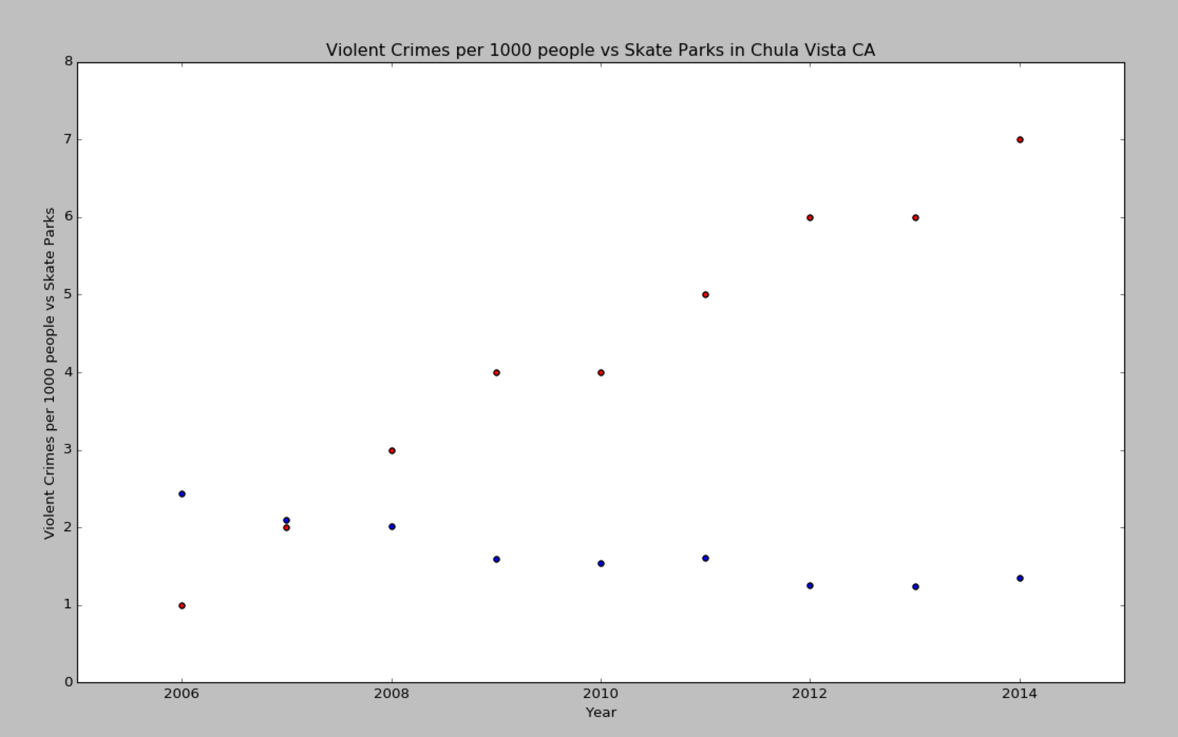
Skateociety, a famous skateboarding magazine in the United States, reported that Chula Vista, California has the most skate parks in one city in the United States. There has been a decrease in youth violent crime across the city according to city-data.com, a website that helps provide crime statistics from the State of California Department of Justice. 2006, the year the first new park was implemented was also the first year that Chula Vista’s violence rate went below the national average. The following data was represented through a scatter plot showing correlation that was coded through python. Red represents number of skateparks and blue represents number of violent crimes per 1000 people.

Despite the legitimacy of this issue and solution, there are some possible counters that limit the feasibility of the argument. The main issue is that skate parks can be seen as ugly and noisy as there is a constant large and loud teenage audience present. However, this issue is easily combated due to the fact that the hours of the skate park could be managed in the same way that your ministry manages the hours of Somerset skate park and others. The method to combat the issue of the possibly negative aesthetic appearance of the park would be to open up the park to current modern art, turning the space into a location where people can fulfil many passions. Somerset also had a similar approach, allowing the space to be tagged on and open to graffiti artists. This not only allows for more crowds to enjoy the space, but it increases the aesthetic appeal of the site.
Lastly, the legitimacy of this project still stands because it will also change the reputation of skateparks and skateboarders, mainly from the police perspective. The Tony Hawk Foundation interviewed 102 police officers in 37 states who had jurisdiction in areas where THF had donated skate parks, several interesting results came from this data collection process. The first was that 90% of officers surveyed believed that the skatepark was an asset to the community, one officer in Maine stated that ““The skaters are very respectful, and the skatepark has cut down on the youth crime, especially vandalism and kids skating on the sidewalks. The park gives the kids something to do, especially the ‘at‐risk’ youth.” In addition, the survey also found that 85% of officers reported that there was a decrease in complaints regarding “skate-related crimes”.
The Punggol community and all of Singapore would really benefit from the implementation of skate parks. They would not only provide an outlet for at-risk youth, but they would also allow for a decrease in youth crime and arrests here in Singapore.
I seriously hope that you consider this solution to a major hidden issue here in Singapore.

Sincerely,
Andrew Edds

Concerned Resident of Singapore
6 Orange Grove Road, #10-00, The Vantage
Singapore, Singapore 258331

Works Cited
By Theme Latest Data Visualising Data Finding A-Z Advance Release Calendar Publications Publications and Papers Yearbook of Statistics, Singapore Monthly Digest of Statistics Singapore in Figures Population Trends Census of Population General Household Survey Household. "Department Of Statistics Singapore." Statistics Singapore. Department of Statistics Singapore, July 2016. Web. 20 Sept. 2016.
"Crime Data." State of California. State of California, June 2016. Web. 20 Sept. 2016.
Grames, Molly, and Cortney Leverentz. "Attitudes Toward Persons with Disabilities: A Comparison of Chinese and American Students." Attitudes Toward Persons with Disabilities: A Comparison of Chinese and American Students (n.d.): n. pag. Journal of Undergraduate Research, June 2010. Web. 15 Sept. 2016.
Hawk, Tony. "Law Enforcement." SpringerReference (n.d.): n. pag. Tony Hawk Foundation. Tony Hawk Foundation, June 2009. Web. 21 Sept. 2016.
Hawk, Tony. "Tony Hawk Foundation." Tony Hawk Foundation. The Tony Hawk Foundation, Aug. 2016. Web. 20 Sept. 2016.
Internet, By Vision. "City of Chula Vista." : Home. City of Chula Vista, July 2016. Web. 20 Sept. 2016.
Maree, Verne. "Low Crime in Singapore Doesn't Mean No Crime." Sg. Expat Living Singapore, Jan. 2011. Web. 20 Sept. 2016.
Savage, Sam. "The Importance of Recycling Paper - Redorbit." Red Orbit. Red Orbit, 28 Sept. 2005. Web. 18 Sept. 2016.
Web, MSF Corp. "Juvenile Delinquents: Juveniles Arrested." MSF Corp Web. Ministry of Social and Family Developement, Jan. 2016. Web. 20 Sept. 2016.

